# Thanksgiving in Cyprus

**SPECIAL EDITION** I am currently on the road traveling (shocker) and thank goodness I had this blog ready to share. (Note: It was accidentally published for a few short hours earlier this year, but I wasn't actually allowed to publish it yet, so I'm sorry if you already read through this one.)

I was not allowed to tell the stories of Cyprus until now, but I began forming this post while I was still there, hoping to capture as many details as I could for a later time.

Last November (2023), I flew to the east side of Cyprus, arriving in the large city of Larnaca for a few days with Scott. (Emphasis on the first syllable: LAR-nuh-kuh)

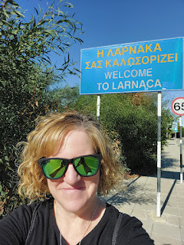

Day One:

To get there, I flew from Venice to Vienna, Austria for the shortest layover I've ever had. Only 25 minutes!! Before I even decided whether or not to buy this ticket, I did some research because that amount of time is unheard of. Thankfully, everything I read about the Vienna Airport was glowing and good. They are super-efficient, and their terminals are stacked on top of each other, rather than spread out. With Austrian Airlines, I flew into Terminal 3 and then I also left from Terminal 3.

When I got off my plane in Vienna, there was a young man directing those of us who needed to make the tight connection to Larnaca to go over to his van on the tarmac. He drove us personally - all 3 of us - to our own passport control booth and then all we had to do was shimmy up the escalator and take a short walk to our gate. How fantastic!

It helped that we got in 10 minutes early from Venice, and it also helped that our flight to Larnaca was a few minutes behind schedule, too. That allowed me to use the bathroom and grab a Coke Zero to try to fight a massive headache that I had.

Oh yeah, I was at the tail end of a bad cold as I made my way to Cyprus. All the changes in altitude caused me to have a really bad headache, the kind where it feels like there are tentacles of pain curling and wrapping around your entire scalp. I did a 1-2-3 punch before I left Vienna and it worked: Advil + Coke Zero + my Deep Relief essential oil on the base of my neck. Every chance I got that day, I closed my eyes to rest. That also helped.

Looking out my window as we prepared to depart Vienna . . . those clouds . . . sooo beautiful . . .

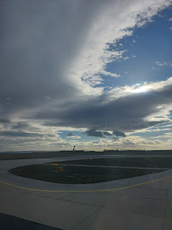

Vienna down below, surrounded by snow-capped mountains . . .

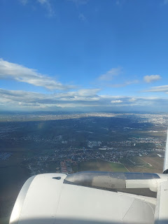

Somewhere on the outskirts of Vienna, with verdant green pastures and plentiful farmland . . .

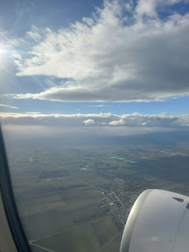

I checked Google Maps from time to time to see where we were on the way to Cyprus. We flew over Hungary, Serbia, Bulgaria, Greece, and Turkey.

Finally, we began our descent to Cyprus. You can see part of the peninsula sticking out below . . .

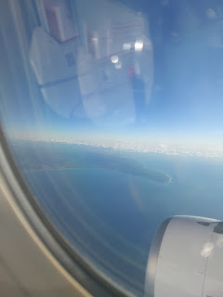

I was surprised that Cyprus had mountain ranges in the middle . . .

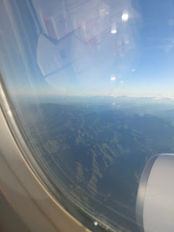

(And I'm sorry about the glare on my window . . .) The squiggly roads were quite interesting, too.

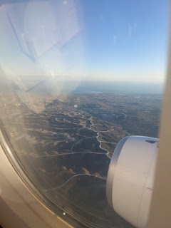

Video #1 of the Cyprus landscape: (31 seconds)

https://photos.app.goo.gl/UTYxBShTS525AR7C8

Video #2 of the landscape: (15 seconds)

https://photos.app.goo.gl/NP2Hv2Q7T6iGF7EF9

As we circled around to land, I saw a naval ship out in the water . . .

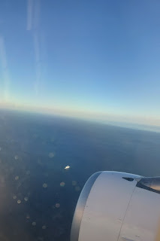

Video #3 of what I thought was maybe Israel or something, but nope. It was all just Cyprus when I checked my video against a map later on. Nevertheless, enjoy: (45 seconds)

https://photos.app.goo.gl/1ogi4cRVUvd1p3rv7

Video #4 of the Larnaca shoreline and harbors: (36 seconds)

https://photos.app.goo.gl/QShPwDzGJUsKxVQP7

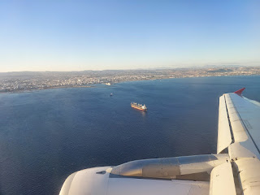

And lastly, video #5 as we came in for our landing: (40 seconds) **You can see the Salt Lake beyond the tall buildings at the shoreline. I walked to the Salt Lake the following day, trying to find the flamingos . . .

https://photos.app.goo.gl/2WGbPBj7k8mWVADn7

Scott helped me figure out ahead of time which bus to take: #425.

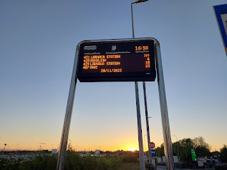

They accept euros for payment here, even though it's under British influence. They also drive on the left side of the road. It helped that I had some experience on public buses lately, because in Larnaca there are no official bus stops. By official, I mean ones that are visibly obvious - there's typically a sign and a bench. But not here. You just gotta "know".  Apparently, there's an app that you can use, and it tells you where to go, but there's nothing else otherwise.  I knew to watch for the Best Western Hotel, so as soon as I saw it, I pushed the "Stop" button next to my seat and the driver pulled over to let me off. Scott was already standing there waiting for me, my dreamboat and my hero. XOXO

Thankfully, Scott goes to bed really early each night, because I was ready to go to sleep by 8:00 p.m. My headache was back so I knew that sleep was important to help squash my symptoms once and for all.

Day Two:

After a nice breakfast downstairs, I was feeling a little dizzy and my headache was trying to creep back, so I wisely chose to climb back into bed after I had eaten. I closed my eyes for about 1.5 hours and that really helped!

Finally, I was ready for my first adventure in Cyprus. I wanted to see the flamingos that migrate here during the winter months. It was a good long walk of 45 minutes. Here are some things I saw along the way . . .

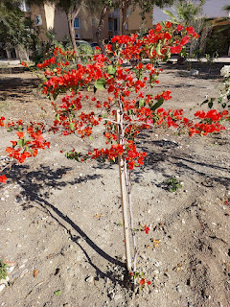

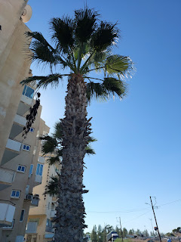

Can you read any of this sign? I couldn't, ha ha. It's all Greek to me! LOL

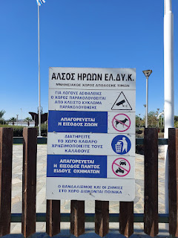

A beautiful memorial and symbol of peace near the Salt Lake . . . The wording underneath the figures was difficult to translate (using Google Translate on my phone). I got a few different translations, but the best one was: "The Immortals ~ Cyprus is Grateful."

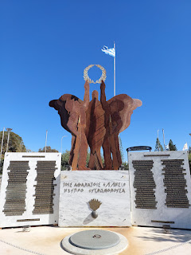

The official languages of the island are Greek and Turkish, but everyone seems to also speak English fluently, which was nice for me. The whole time I was there, I was trying to figure out who the locals were, though, because there are so many tourists and so many unfamiliar languages all around. I heard Greek, Italian, German, and French, to name a few. Russian is also popular there, I'm told.

Even though the Salt Lake isn't FULL, it did have some water that sparkled in the sunshine and reflected the bigger city buildings across the lake.

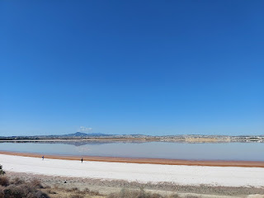

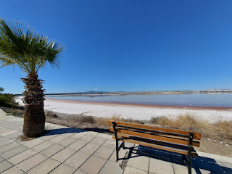

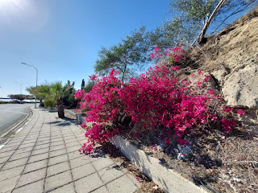

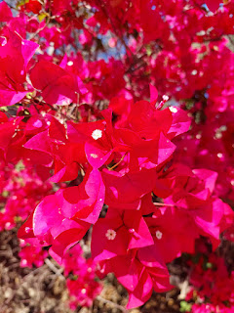

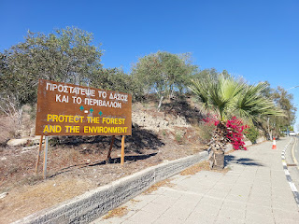

Google Maps had directed me to a spot called "Flamingo Observation Point". Unfortunately, this end of the lake was mostly dried up and there were no flamingos to be found . . .

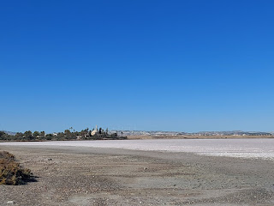

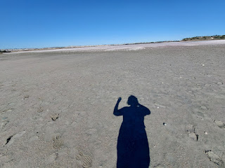

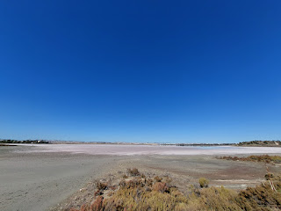

So, I started the long walk back to the hotel in the sweltering sun. There are signs everywhere to remind drivers to stay on the LEFT side of the road . . .

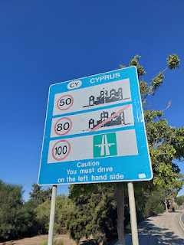

And surprisingly, I saw a few people walking IN the Salt Lake. I tried to get close, down at the dried-up end, but it was so muddy and mucky that my shoes were becoming engulfed with the muddy muck. Blech. I guess some people didn't mind that part in order to get out to the water.

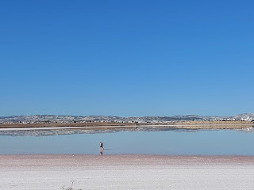

But also, there were signs posted in numerous places that said it was prohibited to be IN the lake and that you would be prosecuted . . . but maybe the locals know something the rest of us don't know? Or maybe these were tourists that just didn't see the signs . . .

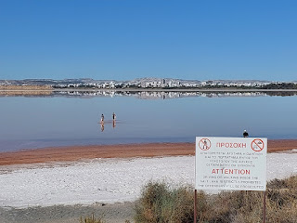

It was a shallow lake because I saw these two guys halfway out in the water, and it was only up to their shins. Maybe they were trying to get close to the flamingos that were on the opposite side of the lake from where I was. It felt like it would take too long to get over there to see the flamingos, and I was pretty hot and sweaty. So, I opted to just keep walking back to the hotel.

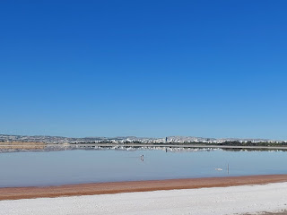

Some carports are nicely decorated with plants and cute decor. The carports are underneath all of the tall apartment buildings.

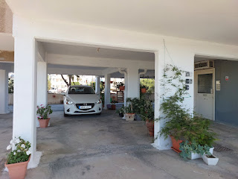

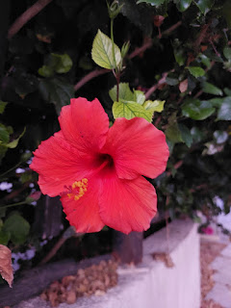

There are several small convenience store sized markets in Cyprus. Many of them are called Mini-Markets. Some items are more familiar than others . . .

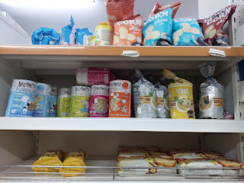

"Keik" for cake, ha ha . . .

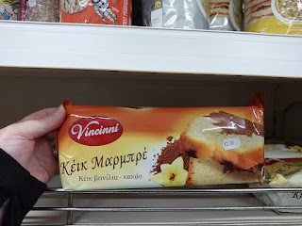

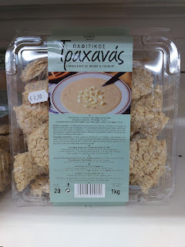

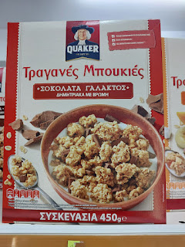

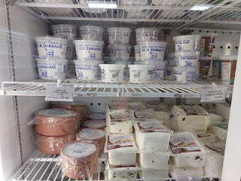

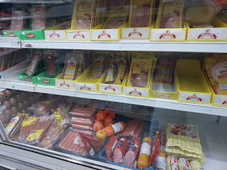

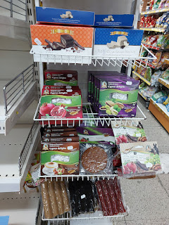

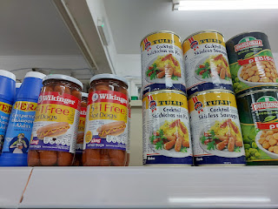

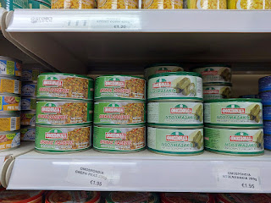

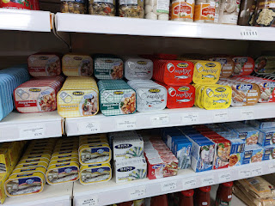

I thought it was funny that they said, "Wanilia" instead of vanilla on the yogurt . . .

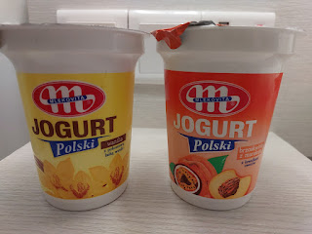

Day Three:

Cyprus has a large population of cats. They are everywhere. Some of them look healthy and happy, while others mew longingly at you, wondering if you have any food to share with them. This cat was friendly and chatty, trotting along the cement wall next to me as I walked by.

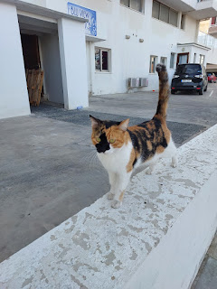

Our hotel, the Best Western Plus in Larnaca, is really close to the Mediterranean Sea. It's maybe a 5-minute walk.

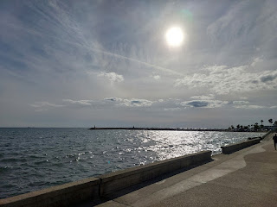

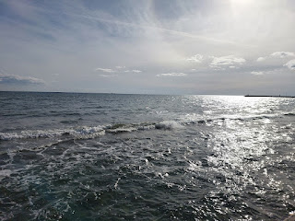

Video of the view from the boardwalk: (9 seconds)

https://photos.app.goo.gl/a4RawdfmoV86Ahqz5

At the northern end of the boardwalk sits the Medieval Fort of Larnaca. I didn't go inside this time, but Scott and I went together a couple days later.

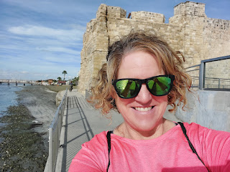

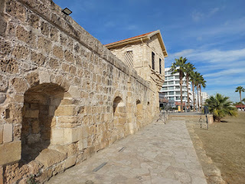

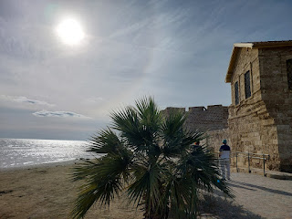

Behind the Fort is the Djami Kebir Mosque, possibly the first Ottoman Mosque in Cyprus. It was originally a Catholic church during the 13th-14th centuries, before it was converted. I did not go in, but just admired its beauty as I continued on my walk.

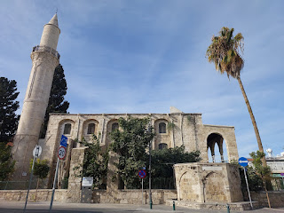

Of course, I took notice of the old headstones in the tiny cemetery out front, though, before moving on.

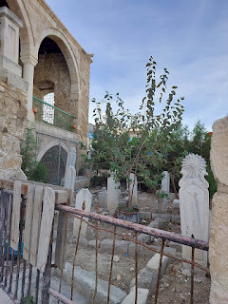

Greek Orthodox is one of the main churches throughout Cyprus. While 78% of the population is considered Christian, they are made up of churchgoers who mainly attend the Greek Orthodox Church, the Armenian Church, the Maronite Church, Roman Catholic, and the Protestant Church. There is also a small group of members who attend The Church of Jesus Christ of Latter-day Saints there in Larnaca.

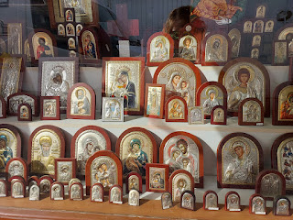

I loved the old, weathered doors on some of the buildings . . .

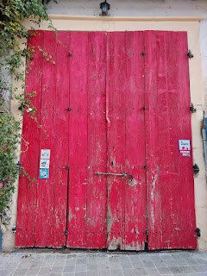

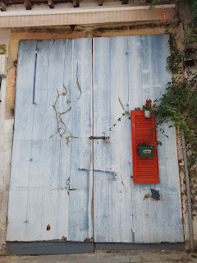

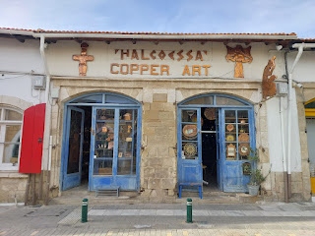

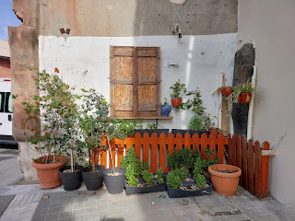

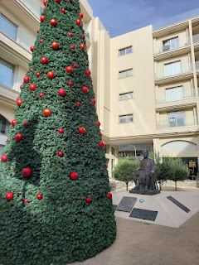

Click this next photo to zoom in and see what the soldier on the right has to say (he's standing next to the entrance) . . . LOL

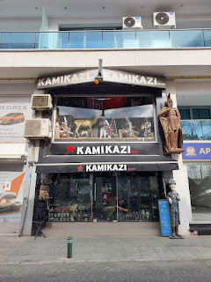

I did a little bit of shopping downtown, finding a few souvenirs that will make some nice stocking stuffers for Christmas, and I also found a cute and inexpensive dress.

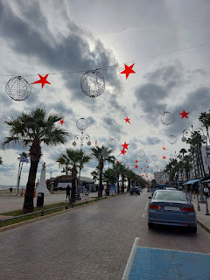

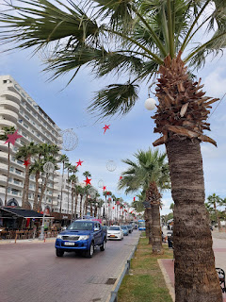

On each large public beach, there is a giant fish to place your empty plastic water bottles for recycling.

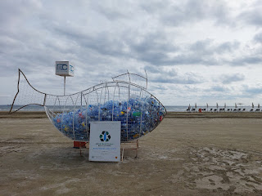

And I was so hoping to see this giant Christmas ornament decoration on the pier when they lit everything up at night, but they were holding out until their special Tree Lighting Ceremony on Dec. 3. Sadly, I was long gone . . .

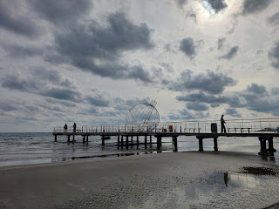

I'm not sure where he learned this, but Scott told me something recently that I thought was really interesting. In the history books, Venice conquered many lands long ago, but there is a clue to how they came to be in power of each municipality within each town. If you find the Lion statue in a public square, the Venetian symbol of rule, look to see what the Lion is wielding.  If the Lion is wielding a sword, then supposedly they conquered this city by force. If he is wielding a book, then the Venetians and this other city or country formed a partnership through education.

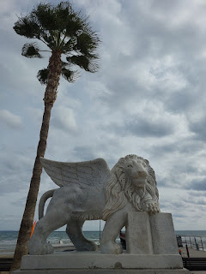

I tried Googling this explanation, but all I could find were numerous articles about how the Lion is associated with St. Mark and how the open book (as seen above in Larnaca) represents a scripture in the New Testament that says Mark was told that he would be laid to rest in Venice. Also fascinating . . . I'll have to ask Scott where he heard the other explanation.

Near the Lion statue at Finikoudes Beach in Larnaca is a collection of tributes and artistic devotion to the citizens of Ukraine. One of the painted rocks, shaped like a heart (in the lower left of the photo below), says: "My Heart With Ukraine".

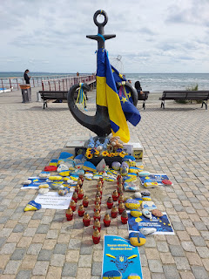

The flowers are vibrant and bright here, which is a nice contrast with all the beige and tan of the buildings and sandy beaches.

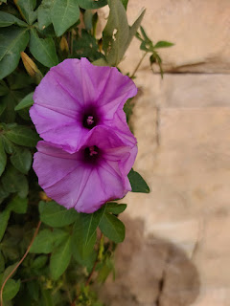

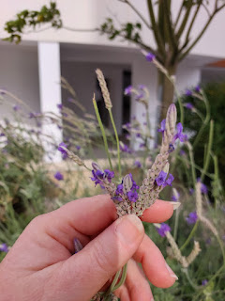

Video of a guy playing his guitar next to the beach as I walked back to the hotel: (13 seconds)

https://photos.app.goo.gl/w8tubNe4P4uHifRj7

Day Four - Thanksgiving:

I went for a morning walk while Scott had a few other things to attend to.

I saw some pretty flowers and citrus on my walk back to the hotel . . .

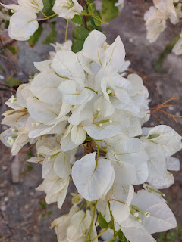

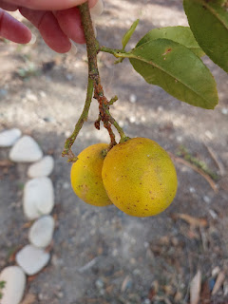

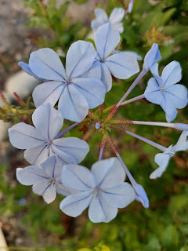

This is the street where our hotel was . . .

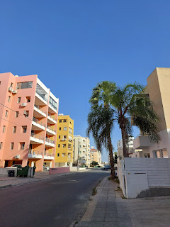

Once Scott was ready, we went on our first big explore together. We walked down the boardwalk to visit the Medieval Fort that I had seen earlier in the week.

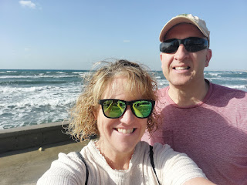

The wind made the waves quite choppy and exciting that day. There is a lower promenade next to the water, and we could see why there is a glass wall and an UPPER promenade - for those crazy wave days where you didn't want to get splashed, ha ha.

Video of the water along the promenade: (15 seconds)

https://photos.app.goo.gl/w5qAZ6adTsLJkXTMA

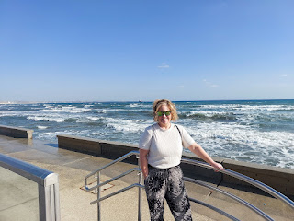

The medieval fort is also called Larnaca Castle, originally built in the late 1300's. (click photo below to enlarge)

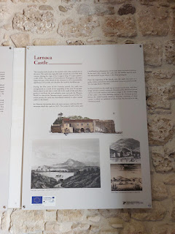

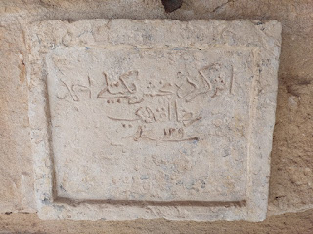

Part of the Castle was used as a prison for a time, and below, Scott is looking at the Galley area where terrible things happened. Hangings and torturing . . . why do we do these things??

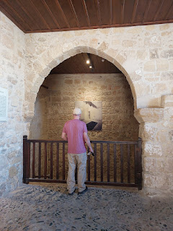

Upstairs in the tower is a museum with ancient carvings and pottery and artifacts.

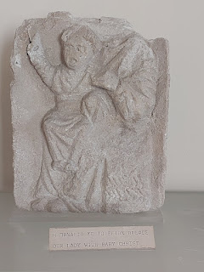

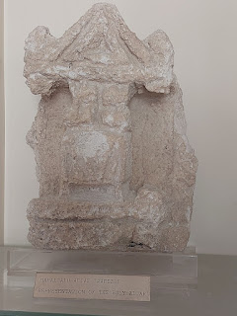

Clay lamps from the 2nd - 6th centuries AD.

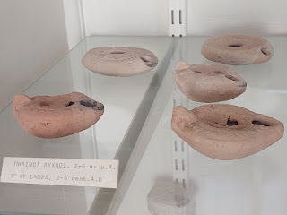

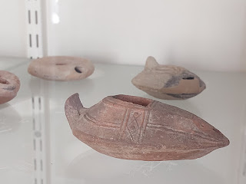

"Stone seals for marking breads" . . . I had not heard of this before . . .

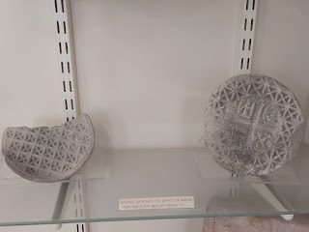

Some words may have been lost in translation for this next one:

"Saint Nikolas of the Roof: Nativity. 13 - 14 cent. A.D."

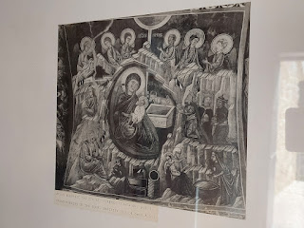

"Kalogrea: Christ Antiphonitis : Angel" . . . no date given

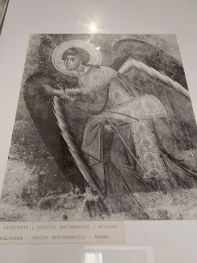

Brown and green "sgraffito ware", 14th century A.D. Sgraffito means "scratched". The artist would paint on a first layer. Then later, they would add a second layer and scratch off a design to reveal portions of the first layer.

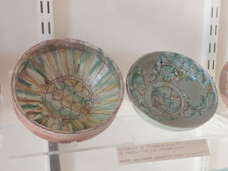

More of the same. 14th century A.D.

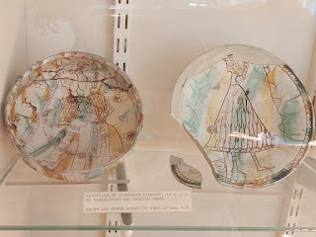

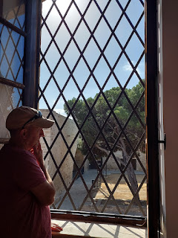

A very old cannonball . . .

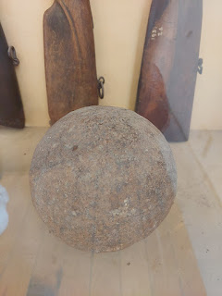

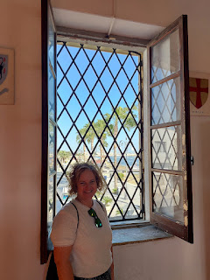

One of several very old tombstones that are now just leaning up against a wall . . .

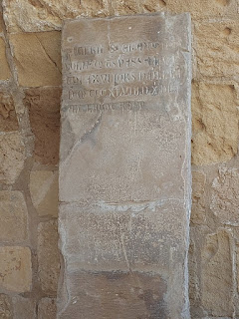

History and Art: in an outdoor alcove, there is a combination of ancient headstones mixed with contemporary art.

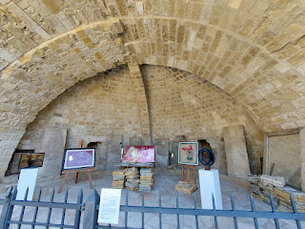

We peeked into each room around the courtyard. Some of the contemporary art was weird, others were just mildly interesting.

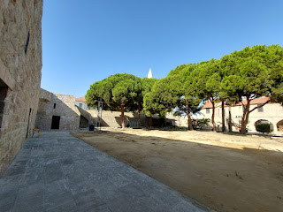

I liked this piece of art, though. It was made to resemble a prayer rug. The description is given below.

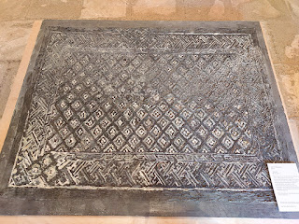

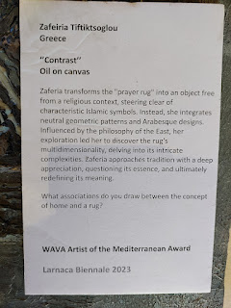

Another ancient and restored headstone . . .

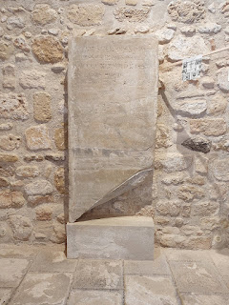

This next artist's rendition was quite beautiful . . . (description below)

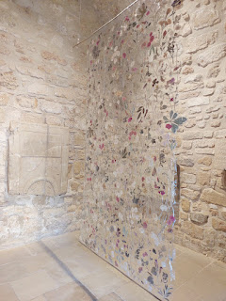

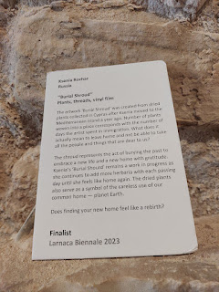

Short video of the above symbolic "Burial Shroud": (13 seconds)

https://photos.app.goo.gl/Lv86rAPDCAKE5csQ9

In the same room, Scott was noting that some of the characters on the wall were similar to Arabic. Similar, but not quite . . .

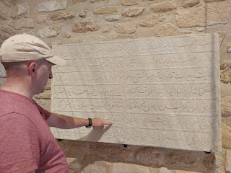

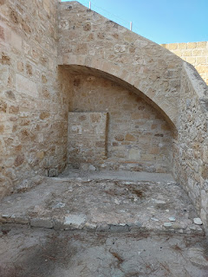

These markers looked like a really big family that are all gathered for a photo, ha ha . . .

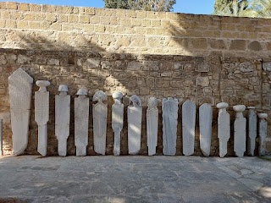

Some old German guns, now in Cyprus . . .

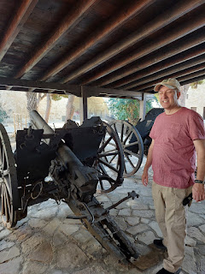

Short clip of Scott, with a funny thing he happened to say while I was filming: (7 seconds)

https://photos.app.goo.gl/LL2QrgAyXnph8mAL6

Video as we passed through a small tunnel up on the roof: (9 seconds)

https://photos.app.goo.gl/RpU5bHN6o7ZcYc4aA

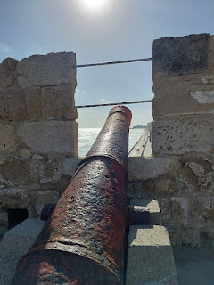

View looking north from on top of the fort . . .

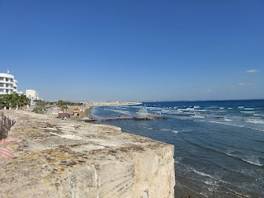

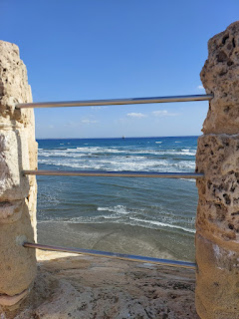

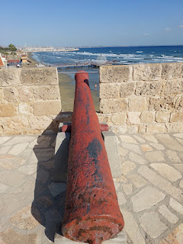

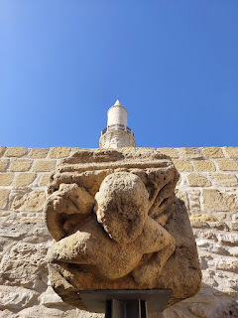

A very old water source, now fitted with modern-ish fixtures . . .

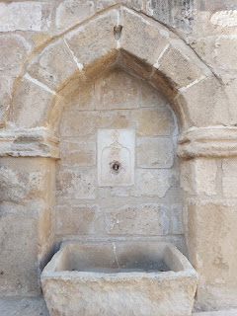

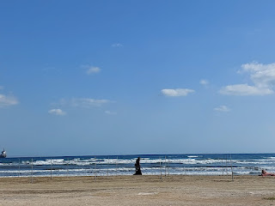

We stopped for some gelato, which was very refreshing. I chose mango along with a new kind that is unique to Cyprus: Kaimaki (sitting next to the bright pink flavor in the photo below).

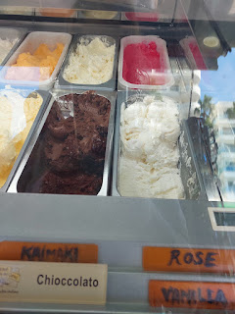

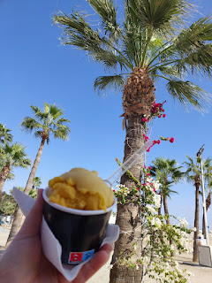

The Kaimaki was so interesting! It was difficult to pinpoint what the actual flavors were, but I could detect a hint of nutmeg or clove. It was really, really good!! So good, in fact, that I hunted down a recipe. The author gives a description of each spice that goes into the ice cream.

https://freshpiato.com/fast-and-easy-kaimaki-ice-cream/#:~:text=Its%20taste%20is%20unique%20and,%2C%20ice%20creams%2C%20and%20desserts.

We walked past the beach and past the carnival area, on our way to a scooter rental store to possibly rent some electric scooters for a couple days.

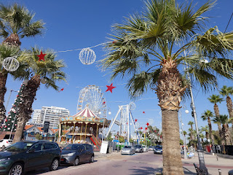

Unfortunately, though, the company with the best reviews also sells their scooters at the end of the summer season to make way for new ones in the spring, so they didn't have any for us to rent in November. They had some shiny Vespas to rent, but the guy didn't understand Scott's motorcycle endorsement on the back of his US driver's license, so those were not an option, either. Ultimately, we decided to just rent a car, which turned out to be amazing.

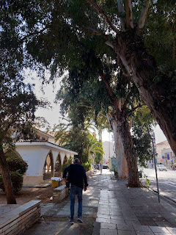

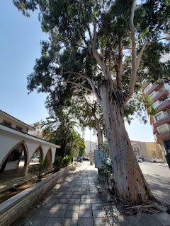

Next, we walked over to see the Holy Church of St. Lazarus, about a 5-minute walk from the Vespa rental place.

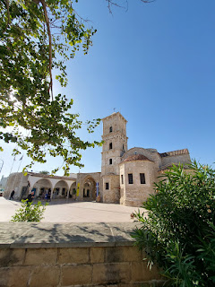

The Holy Church of St. Lazarus is a late 9th century church in Larnaca. According to Wikipedia:

The Church of Saint Lazarus is named for

New Testament

figure

Lazarus of Bethany

, the subject of a miracle recounted in the

Gospel of John

,

[1]

in which

Jesus

raises him from the dead. According to

Eastern Orthodox

tradition, sometime after the

Resurrection of Jesus

, Lazarus was forced to flee

Judea

because of rumoured plots on his life and came to Cyprus. There he was appointed by

Paul the Apostle

and

Barnabas

as the first

Bishop

of

Kition

(now Larnaca). He is said to have lived for thirty more years and on his death was buried there for the second and last time.

[2]

The Church of Agios Lazaros was built over the reputed second

tomb

of Lazarus.

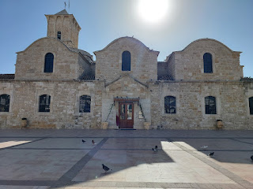

The article had a few more interesting bits to share, so if you're wanting more, click here:

https://en.wikipedia.org/wiki/Church_of_Saint_Lazarus,_Larnaca

The interior of the church consists of many influences: Early Christian, Roman Catholic, Ottoman, Greek Orthodox, and has inscriptions in Greek, Latin and even French.

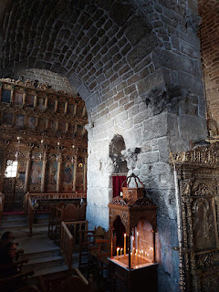

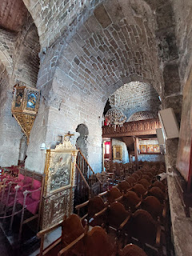

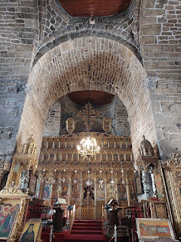

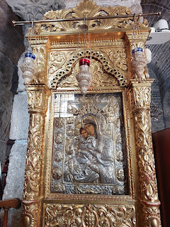

Video of the interior: (13 seconds)

https://photos.app.goo.gl/o5k94X241b9hmcrh6

That's when I saw a sign pointing the way to the Tomb of St. Lazarus: (10 seconds)

https://photos.app.goo.gl/KF5ydcTDb6LuN5Mg7

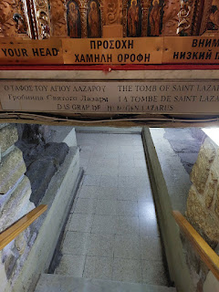

Video going down into the crypt: (25 seconds)

https://photos.app.goo.gl/q3PaBTL6MrzCB8i7A

There was nothing specific down there to indicate where Lazarus had been buried, but I guess it was enough to know that he was, in fact, buried there at one point.

A lady came in to fill two water bottles with what is considered to be "holy water".

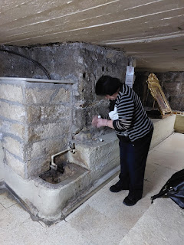

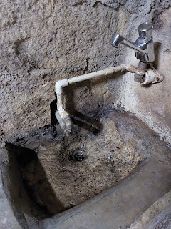

Several other open and empty tombs are down in the crypt. While I didn't SEE anything pointing me to Lazarus, I definitely felt my heart go pitter patter when I first went down the steps. I do believe that he was there at one point.

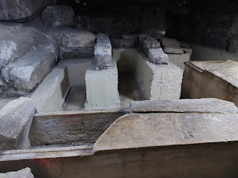

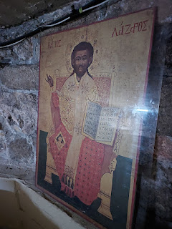

The ceiling is very low in the crypt . . .

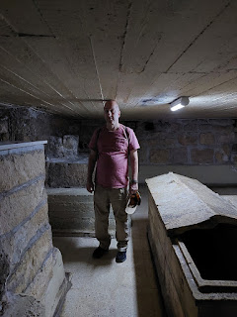

Everything is very ornate with the Greek Orthodox style. Lots and lots of gold.

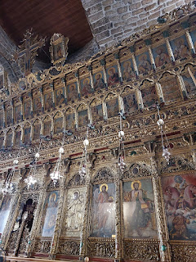

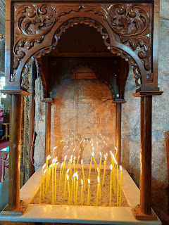

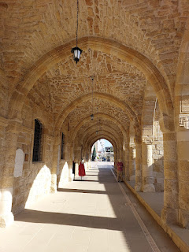

There was a museum next door, but we didn't go in.

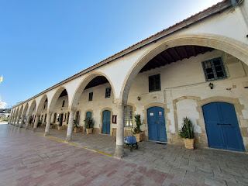

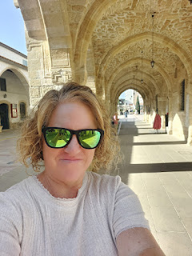

I will definitely cherish this experience, especially when I read about Lazarus again in the New Testament. It felt like we had visited a holy site and I was humbled by it.

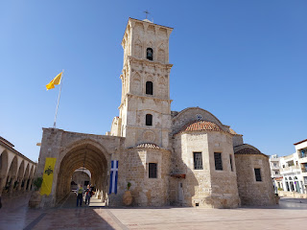

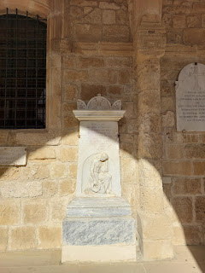

Down the street is a giant billboard with honors being given to St. Lazarus . . .

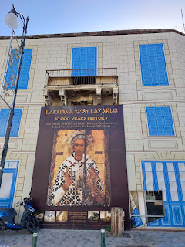

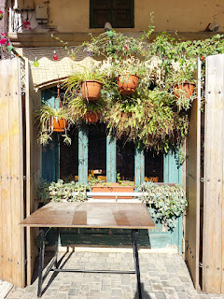

We made our way back to the hotel, where we caught a bus out to the airport to rent a car.

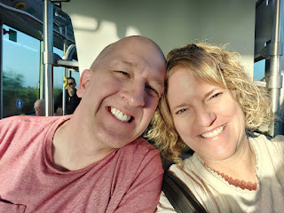

In Cyprus, they try to make it easy for you to drive on the left side of the road (the wrong side). There are bright blue signs with arrows pointing you to the left at every intersection, which really do help. However, it was still a little nerve-wracking as we prepared to drive away from the airport, ha ha.

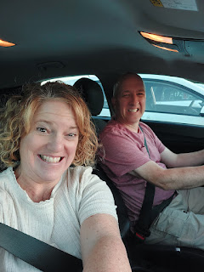

But Scott did great! On his mission to Scotland (1988-1990), he drove on the "wrong" side of the road there for two years. While he hasn't done that since, he picked it right back up and got us everywhere safely for the next 3 days.

Our first stop was for Thanksgiving dinner. We had chosen a place called Enalia, located a few minutes south of Larnaca. Everything was charming and inviting throughout the restaurant, with great attention to detail.

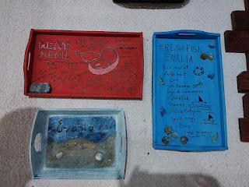

Even the platter of fruit inside the entrance was welcoming and full of positivity.

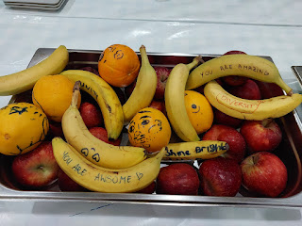

We sat outside on a large patio, with snippets of sunset views in between trees and shrubs. Something I LOVE about Cyprus is that I never encountered a single mosquito!! How delightful is that.

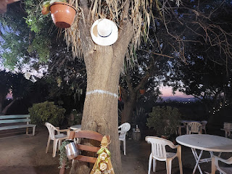

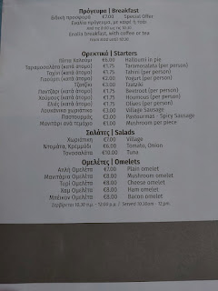

We ordered a Village Salad for a starter, and I ordered the Red Mullet (per the waitress' suggestion), while Scott ordered chicken.

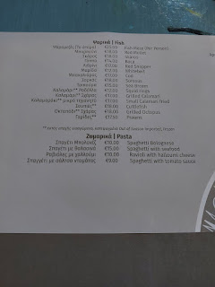

The Village Salad consists of: tomatoes, green bell peppers, cucumbers, red onion, feta cheese, and olive oil and vinegar drizzled over the top. The only difference between the Village salad and a Greek salad is the size. We could have used a smaller size, but we loved it!! Everything was so fresh and so flavorful.

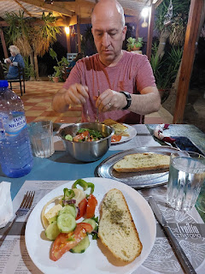

Happy Thanksgiving to my Bestie.

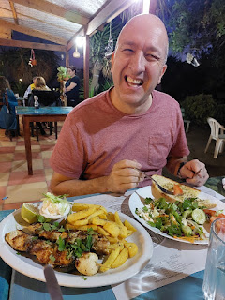

My Red Mullet was delicious, too. I ate 95% of it (them), Scott helped me eat a little, and then we fed some scraps to the kitty that was hanging out nearby.

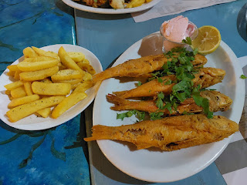

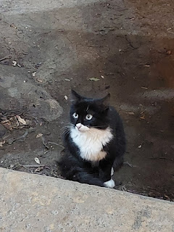

Video of the kitty: (8 seconds)

https://photos.app.goo.gl/8Nd24hSNy54kF6YSA

We learned that our waitress was the owner of Enalia, along with her husband. Her name is Foodini (sp?) and she has been in Cyprus her entire life. Her parents and grandparents had to relocate from the north part of Cyprus to go further south when the Turks came in to "occupy" the north in 1974. It was a devastating experience for their family.

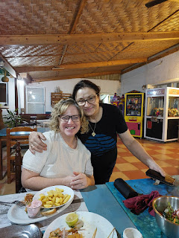

While it appears that the Turks "own" northern Cyprus on a map, it is a very fragile conversation to have with a Cypriot. They do not refer to it as the Turkish North, but rather the "occupied" north. In their minds, the Turks just live on Cypriot land. There is a demilitarized zone run by the U.N. that separates the north from the south. Scott was not allowed to cross over into the north, which made me sad because the Monastery of St. Barnabas is in the north and I really wanted to go see it.

Foodini brought me out a traditional Cypriot dessert, but I don't know the name of it. It was not on their menu, and I can't find it on any website with pictures of traditional desserts, either. It was creamy and delicious! I asked her about the black candied piece on top. She explained that it comes from a walnut! In Cyprus, they take the walnuts when they are still green and then they make them into a dessert. They are soaked in some sort of brine until a syrup is made. And that's where I got lost, ha ha.

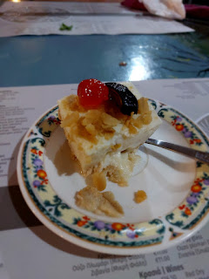

Here is a YouTube video on how it is made: (7 minutes)

https://www.youtube.com/watch?v=7jZDwxu9PdI

The black walnut (Glyko Karydaki) is delicious, but I had no idea it took so long to make them!!

I really enjoyed how Foodini took the time to visit with us at our table, explaining things to us and sharing parts of her life with us. It made our Thanksgiving meal even more special.

The kitty was quite content as we finished up our dinner, too. He really enjoyed the fish scraps. :)

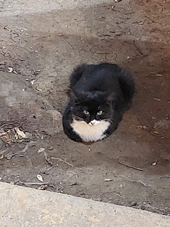

Day Five:

We had two stops on the agenda for the day, both of which would be up in the central mountains. First: Visit the donkeys at Apesia Hills Donkey Park. And Second: Visit the town of Omodos.

We drove south toward Limassol, the 2nd largest city on the island, with approximately 235,000 residents. As we passed by it on the freeway, it definitely felt quite a bit larger than Larnaca.

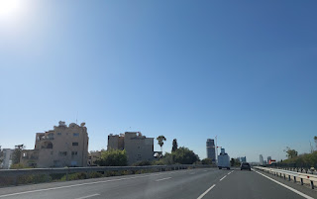

Video going through Limassol: (12 seconds)

https://photos.app.goo.gl/rwW8uSAFfZGw9aF16

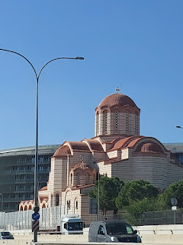

From Limassol, we turned north to head up into the Troodos Mountains. We passed through a tiny village with an even tinier "road" . . .

Video of this supposed "road": (27 seconds)

https://photos.app.goo.gl/LpjLUsVtVctrfN6y6

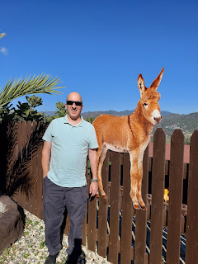

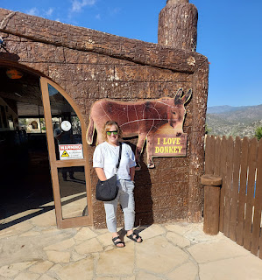

Lots of donkey "welcomes" near the ticket booth and parking lot. All of them were so cute . . .

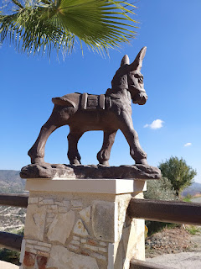

Inside the ticket booth, there are donkey snack bags for purchase. Apparently, they love carob! It looks like a dried vanilla bean and falls off of carob trees.

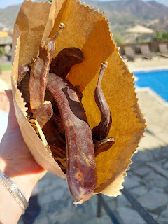

Carob powder can be used as a substitute for cocoa powder. It is also naturally sweet and not bitter, like cocoa powder can be. It is safe for animals and contains no caffeine.

For more information about carob, here is a good link:

What is Carob? (thespruceeats.com)

Bathroom signs in Cyprus . . .

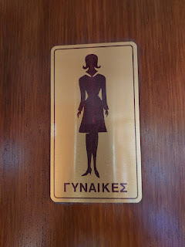

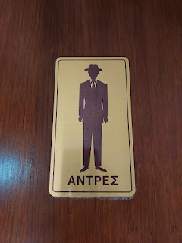

Down a few steep steps from the main level of the shop, is a mini zoo. This would be a delightful place to bring your children!

There are chickens, including this beautiful white one . . .

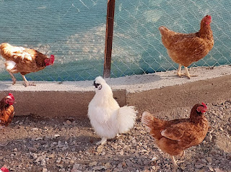

Very friendly deer, with an exuberant curiosity . . .

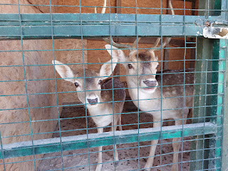

Video of the darling deers: (6 seconds)

https://photos.app.goo.gl/KNJfcQsNYERWqG1r8

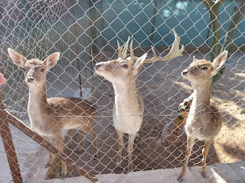

Beautiful peacocks . . .

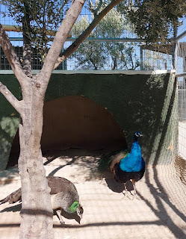

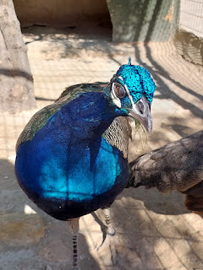

And other birds with colorful plumage . . . there were also sheep, goats, and bunnies.

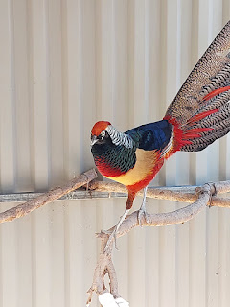

When we were done visiting the animals, we walked up the steep stairs to another set of steep stairs to go around behind the shop. This is where we would be outfitted to ride a donkey!!

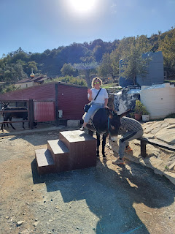

No saddles or stirrups on these guys, just a soft blanket to sit on and a simple rein to hold onto.

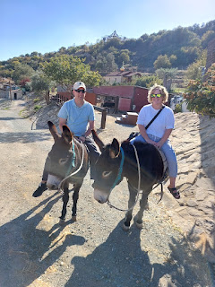

Scott's donkey didn't want to get going at first . . . he needed some encouragement from our guide.

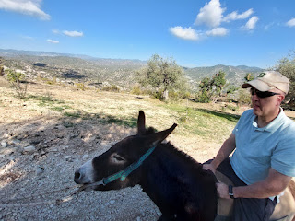

Our guide, whose name was Amman, was originally from India, but came to Cyprus for a better way of life and a good paying job. He has a girlfriend back home and occasionally gets to visit her. He spoke very quietly and with his thick accent, I had to concentrate pretty hard to discern anything he said.

Here he is, pointing to where, in the next couple of weeks, they expected to see some snow. The highest peak in the Troodos Mountains of central Cyprus is 1952 meters (6,404 feet).

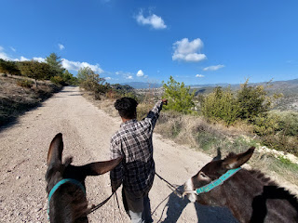

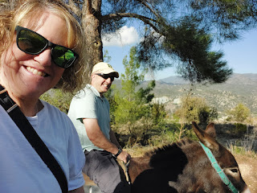

Amman (pronounced like Ah-MAHN) led us to another donkey farm down the road a bit, maybe a 20-minute walk. This is where all the pregnant mommies live. They were being well cared for and looked very healthy. Amman told us that he milks the momma donkeys just once a day, of those that have babies already born. This is so that they still have plenty of milk for their young, too.

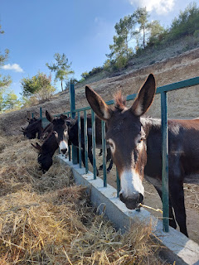

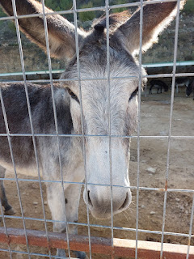

Cute facial expressions . . .

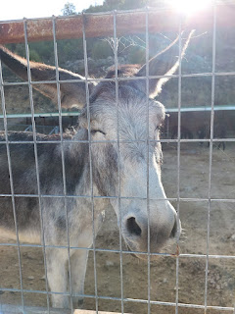

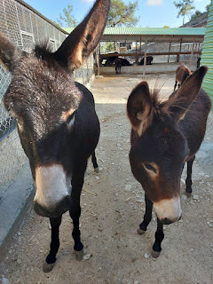

We mainly came all this way to see the newest baby donkey, only 20 days old! He was sure cute.

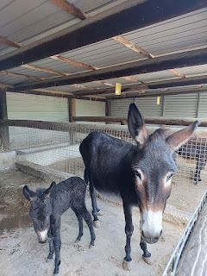

Video of the baby, with a VERY watchful eye from his momma: (8 seconds)

https://photos.app.goo.gl/AxDNDcmjgsZU2Ek49

We opened up the bag of carob treats and everyone got VERY excited, ha ha.

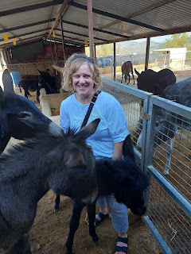

Video of Scott feeding them: (11 seconds)

https://photos.app.goo.gl/BiTjUR6fVMSv83nD9

Video of me feeding them: (12 seconds)

https://photos.app.goo.gl/npLZSKTXB8A5ZdhCA

We had to save a little bit of the treats for our own donkeys, though. After lots of petting (the babies were especially soft) and several friendly nudges from the 15 or so donkeys in the pen, it was time to head back.

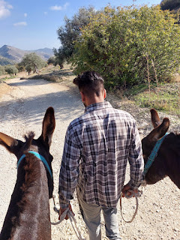

We fed the last few remaining carob pods to our hardworking friends, which they appreciated very much.

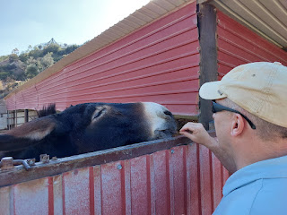

The owner brought out some samples of chilled donkey milk for us to try. Scott was more reluctant, but he was pleasantly surprised that it actually tasted good! I had read ahead of time that donkey milk is full of healing properties. Who knew!?! The milk is expensive (about $25/liter) because donkeys don't produce very much, certainly not nearly as much as cows do.

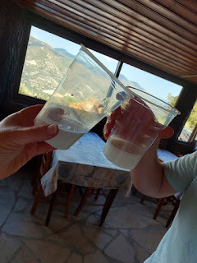

One of the ways that donkey milk is used in Cyprus is for when people have any type of respiratory sickness. They claim that the sickness is all done in roughly one day after drinking the milk. Wow.

These long and slender acorns were a big hit with the deer. We had seen them on the ground, but it was Amman who told us that the deer love them.

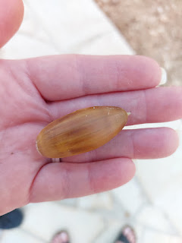

Video of me feeding one of the deer through the fence: (5 seconds) *Scott was filming and at the end he said, "Cut!" HAHAHA

https://photos.app.goo.gl/WvFzJkuDNxNDnHPY8

This photo shows the different levels at the farm. The upper level is where the parking lot and the main shop are located. These steps lead down to the mini zoo, the bathrooms, an outdoor eating area, and a POOL.

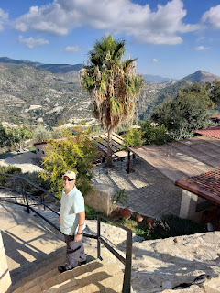

Video of the lower level and pool: (6 seconds)

https://photos.app.goo.gl/39gGbWpPbAAdAYVg7

You can rent the house adjacent to the pool, too! It's on AirBnB I think. Very tempting . . .

After all that donkeying around, we headed off for our next adventure, located a little further north.

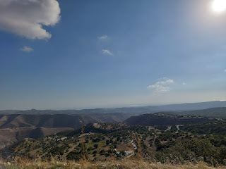

Video showing just how high up we were in the Troodos Mountains: (11 seconds)

https://photos.app.goo.gl/vgUeu14m2eWCo4yaA

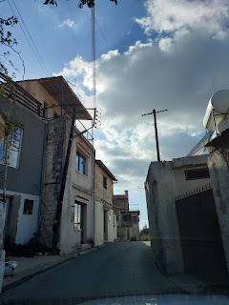

There was a nice variety of scenery on our drive that day. We passed through areas that resembled the deserty and wooded areas of Payton, Arizona, forested curvy roads that reminded us of Idaho, and there were even some pretty yellows on some of the trees for autumn.

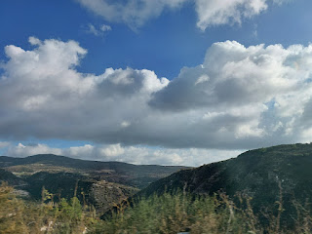

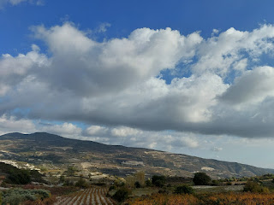

Another kitty in Cyprus . . .

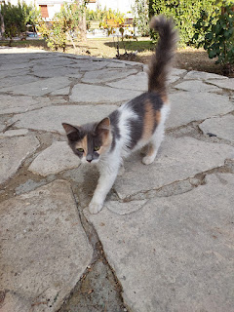

We parked next to a little garden with beautiful blooming roses . . .

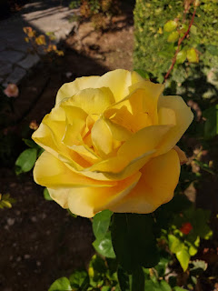

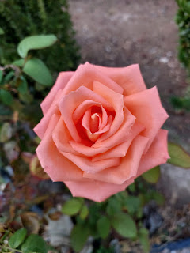

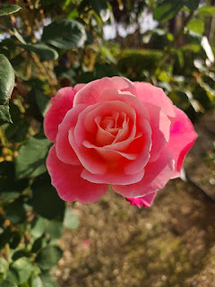

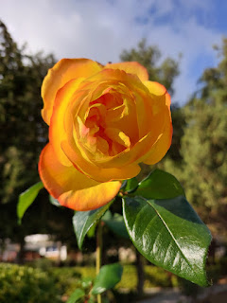

There was a large billboard sign with info about the Troodos Mountains along with a description of many activities that can be enjoyed in each area.

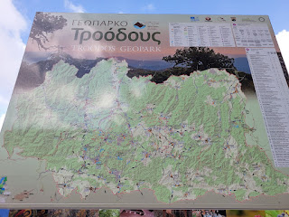

There are UNESCO Churches, Medieval Bridges, and Nature Trails . . .

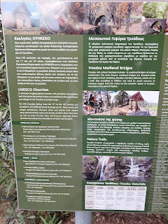

Vegetation and Fauna, Gastronomy (foodie options), and Wine Routes . . .

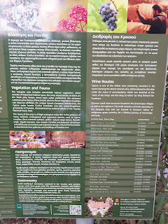

A beautiful grove of trees next to the parking lot . . .

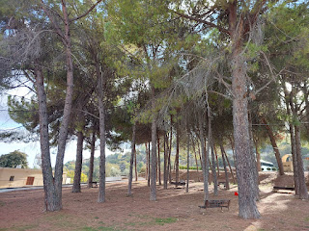

First, we walked up the street to visit the Cypriot Cemetery of Omodos.

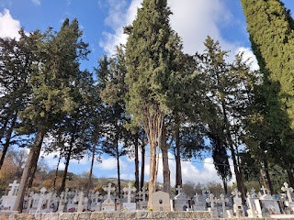

As with many of the other cemeteries I've seen in Europe, Italy especially, photos are included on the headstones of deceased loved ones. I really wish that this would be the traditional method in the U.S.

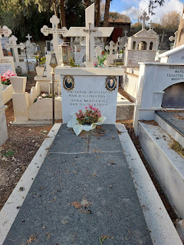

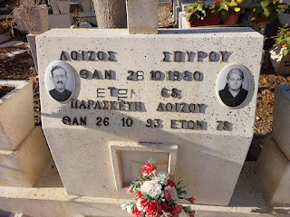

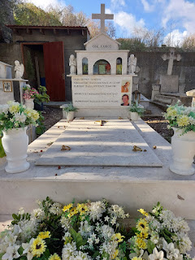

In the photo below, Scott was pointing out to me that family members appear to be buried on top of previous family members.

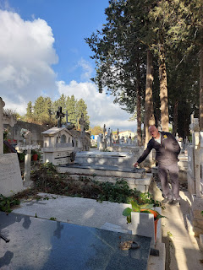

Burial plots are also VERY tightly squeezed and "organized" together.

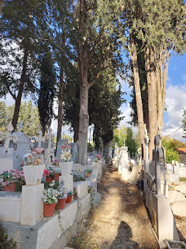

Some local paintings were on display as we walked into town . . .

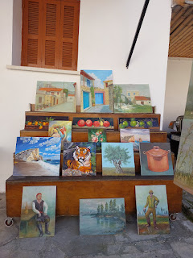

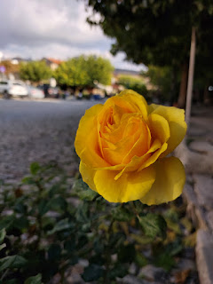

It was definitely a strange feeling to try to connect with Christmas in such a warm climate, but it did help to see the decorations and a Nativity scene on display in the public square.

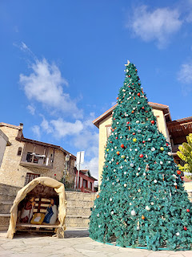

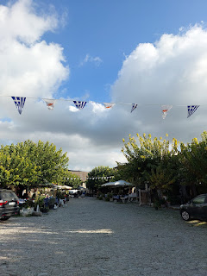

We slowly walked past all the restaurants and souvenir shops as we headed to a special church.

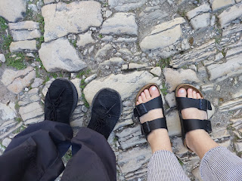

We wanted to see the

very

old monastery known as Timios Stavros Monastery. In English, it is called Holy Cross Monastery or Honest Cross Monastery. A small church was originally built here in approximately 210 AD. The current church was built in 1150 AD as a monastery, with many renovations that took place in the 19th century. This is the oldest monastery in Cyprus.

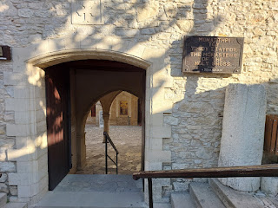

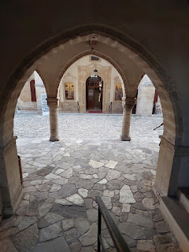

The reason it is referred to as the Holy Cross or Honest Cross Monastery, is because legend has it that pieces of the True Cross (where Jesus was crucified) were distributed to various churches after His death. This church claims to have a piece of the Holy Cross, as well as a piece of a rope with Jesus' blood on it (supposedly). I have a hard time believing in such things, but I always lean on what I FEEL when I go there. If I have a good feeling that this is true, then I believe it. If I have a skeptical feeling or a bad feeling about it, then I don't believe it. I did not find these actual artifacts within the Monastery, so I cannot be certain one way or the other.

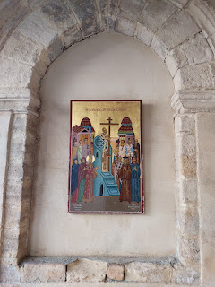

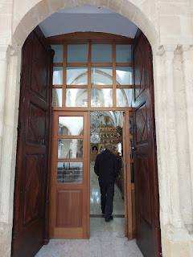

The monastery today has more of a Greek Orthodox flavor, with a lot of gold inlay and other gold features.

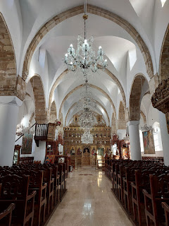

Video of the chapel: (21 seconds)

https://photos.app.goo.gl/tXewXfDYGWaMENWn8

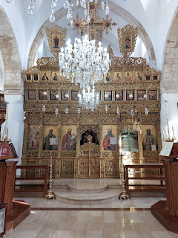

Inside a glass case on the left side of the chapel are some very unusual and slightly creepy relics. This next photo (click on it to zoom in) has a list of all the Saints that the relics pertain to. There is not a detailed description for each one, so you'll have to use your imagination for some of them. I will say that relic #2 is allegedly the Apostle Philip's skull . . .

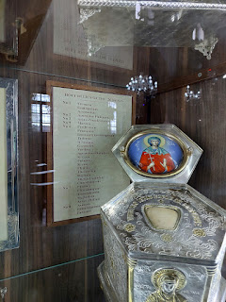

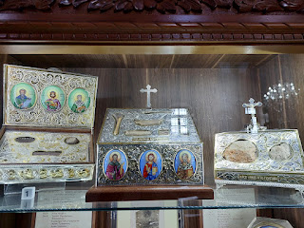

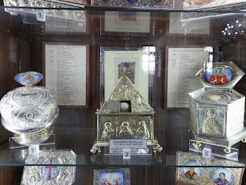

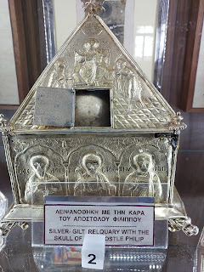

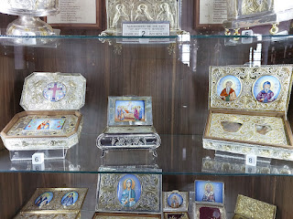

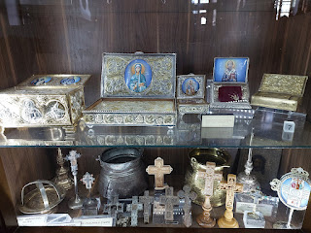

I really loved this framed "painting", an intricate piece with careful and detailed embroidery to represent the Savior as He was being tended to by angels following his Crucifixion.

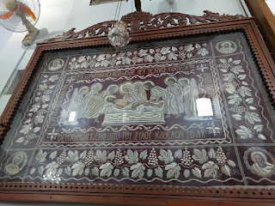

Just outside the main entrance you can donate a little money to light a candle for a loved one if you choose.

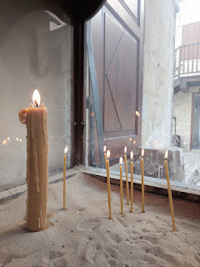

Walking around the exterior of the monastery felt every bit as special as the inside . . .

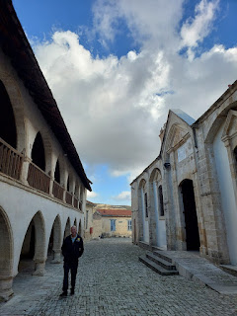

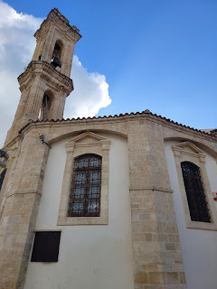

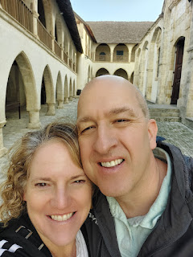

We wandered through some of the narrow streets and alleyways of Omodos, and I just tried to soak in all of the magic along the way.

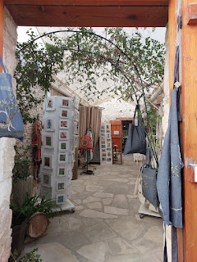

I had read ahead of time that historically, the women of the Troodos Mountains - when they weren't helping their husbands in the vineyards - would gather in small groups to crochet lace. I was thrilled to see this very special shop in one of the alleys.

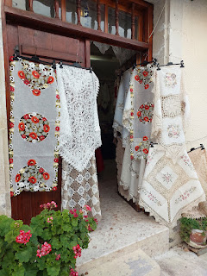

As I stepped inside, I saw this sweet older lady sleeping across the room, with her supplies on her lap. As Scott stepped in behind me, she woke up and instantly beckoned for me to come closer. She wanted to give me a demonstration of her needlework. I'm sure the locals understand how amazing it is for us tourists to see something so unique and special as this.

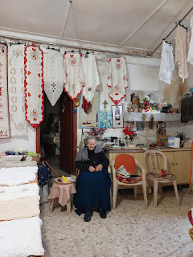

Video #1 of her demonstration: (16 seconds)

https://photos.app.goo.gl/TbgWwDZWgTpkioc4A

Video #2 of her demonstration: (7 seconds)

https://photos.app.goo.gl/qZb7qwSunZn98yY47

The white stone and brick, complimented by a bright blue door, is a common feature of Cyprus. In doing a little bit of research, I found that there were many possibilities for this. It may have something to do with the legend that the color blue wards off evil spirits, as seen in the common cyclops eye that is sold in a variety of forms in Cyprus (on purses, hats, bags, scarves, wall art, etc.). It may also be linked to the color of the Mediterranean Sea. In Greece, which isn't too far away, through the years they would whitewash the buildings with lime to get rid of bacteria, in addition to it creating an insulating barrier against the harsh heat of the sun. Whatever the reason, it is just stunning to see and appreciate as you walk around.

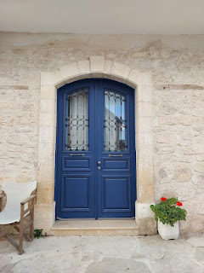

A little bit of Christmas in Omodos . . .

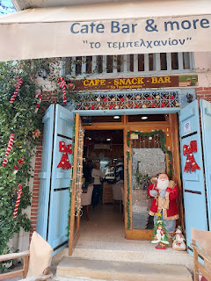

Back to the main cobblestone street, with vendors and restaurants, I came back to investigate the scarves that had caught my eye as we passed them for the first time earlier. I ended up getting a very light mint green scarf, which made me very happy. Scarves in the warmer climates are extremely lightweight and breathable, which is very helpful, especially for those of us with a naturally warmer core temperature.

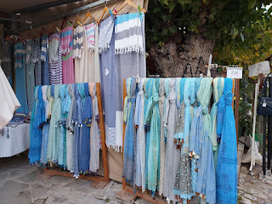

Same shop . . . with some beautiful artwork for sale . . .

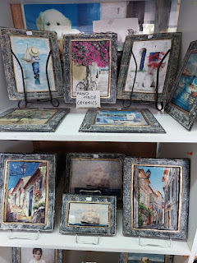

For dinner, we opted for one of the restaurants on the main street out of convenience. I wanted to eat at The Black Geese because it was highly rated, but they wouldn't be open for a while, and we wanted to get down out of the mountains before dark.

We did pop in briefly to The Black Geese and saw that it looked very inviting on the inside, with George Michael singing "Last Christmas" in the background . . .

Video of the restaurant: (7 seconds)

https://photos.app.goo.gl/K4A8APcnVFJckXmB8

We ate at Themelio instead, and it was amazing. I chose the top entree on the menu: Mousaka with salad. (Mousaka = moo-sah-KAW)

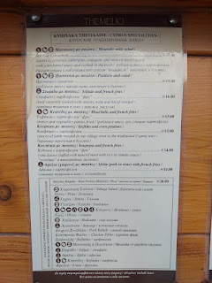

Mousaka is one of those comfort foods that just make everything better. It's sort of like a shepherd pie, but 100x better. There are layers of eggplant and beef, potatoes, and a bechamel sauce that is like a creamy roux with cheese for the top layer. It all just melts in your mouth. I can practically taste it all over again as I'm describing it . . . sigh . . .

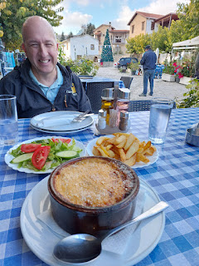

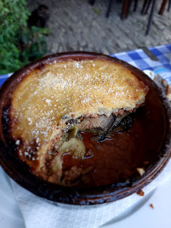

After dinner, we walked back to our car, enjoying a few more flowers on the way . . .

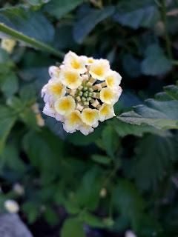

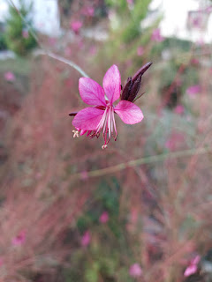

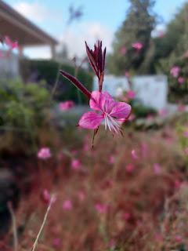

Someone left some bread for the Cypriot cats to devour . . . kinda gross but kinda nice at the same time.

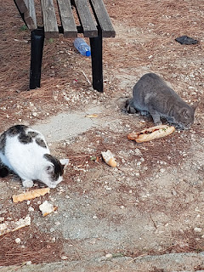

Scott did such a great job driving on the right side of the car and staying on the left side of the road.

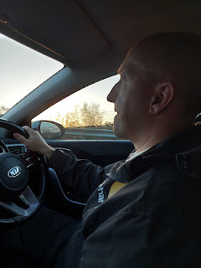

Pretty pink clouds blanketed the sky like cotton candy as we came down the mountain . . .

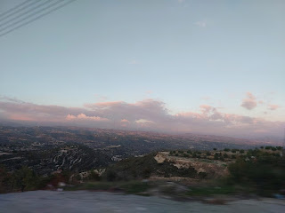

I'm not sure what this building was for, but it might have been a mosque. It certainly was beautiful.

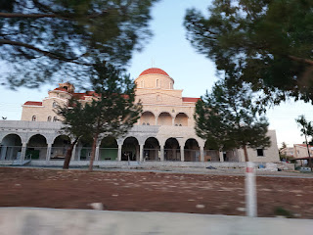

When we got back into Larnaca, we took a walk along the beach. I was hoping to see the Christmas lights lit up along the streets by the old medieval fort, but I was disappointed . . . I think they were saving them for the Tree Lighting Ceremony coming up in another week. But we enjoyed a nice stroll along the water with the moon shining brightly above.

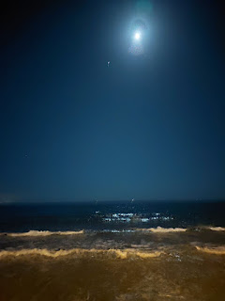

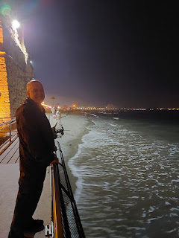

Day Six:

We woke up extra early so that I could see a Cypriot sunrise with my best friend. We walked down to the sea at 6:00 a.m. We passed these unusual and slightly creepy statues, possibly former shipmasts??

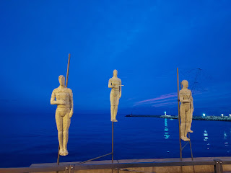

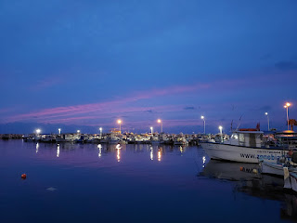

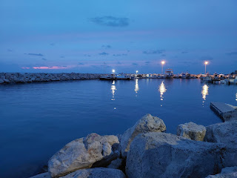

The sunrise wasn't as dramatic as some of the mornings Scott had seen on his daily run, but it was still nice to watch all the fishermen head out for work.

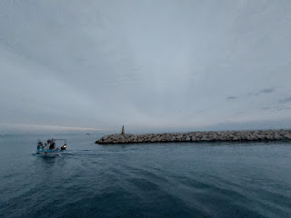

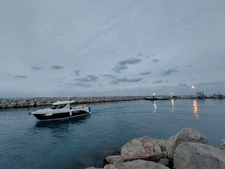

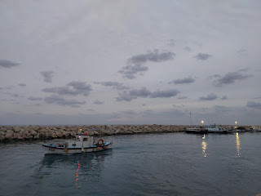

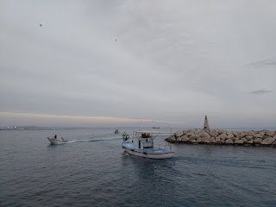

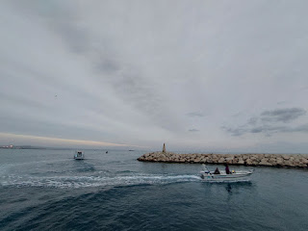

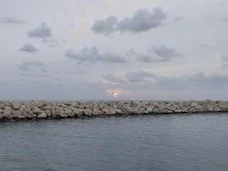

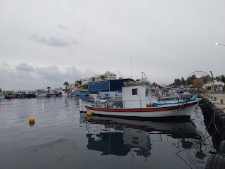

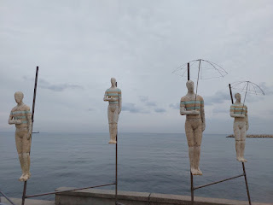

For comparison, Scott sent me this Larnaca sunrise on a different morning . . .

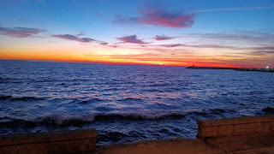

After breakfast and showers, we drove down south again, past Limassol and west toward Paphos. (PAFF-ohs)

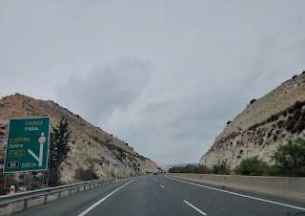

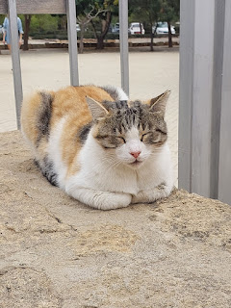

This cat wasn't quite awake to greet us upon our arrival, but that's okay. We came to visit a place called The Tombs of the Kings. While kings were not actually buried here anciently, people of importance were, varying from local leaders such as a mayor, or other community members with wealth and status.

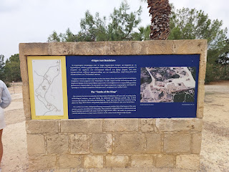

The Tombs of the Kings dates back to the 4th century BC and was most likely used up through the 3rd century AD. Discoveries have been made in recent centuries, the earliest record of this was just before 1800. Archaeologists and scientists have continued to excavate and discover since then, and of course, the artifacts and treasures buried with those ancient citizens are long gone now.

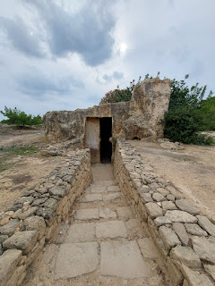

I will share several videos (8 total) of what we saw during our big explore. We listened occasionally to stories and explanations of what we were seeing through an app that Scott downloaded at the entrance. If you want to know more, you are welcome to do some additional research on the world wide web. :)

Video #1: (13 seconds)

https://photos.app.goo.gl/8RtX6WYJtdtJKU6J6

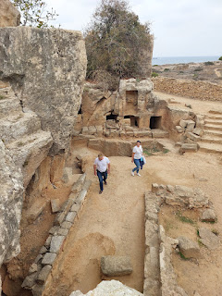

Video #2: (8 seconds)

https://photos.app.goo.gl/VXRn3E3RvneaYkLg7

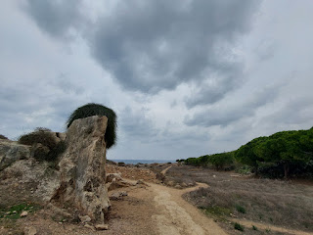

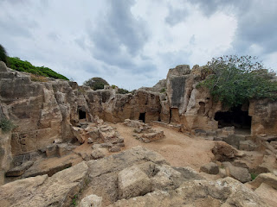

Video #3: (15 seconds)

https://photos.app.goo.gl/k61pThvnig4ZvVmV7

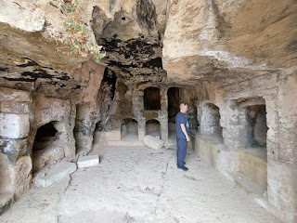

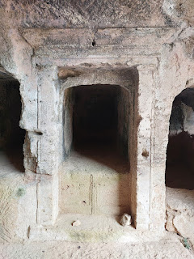

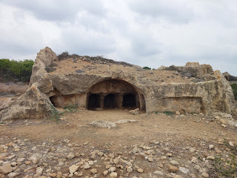

Video #4: (9 seconds)

https://photos.app.goo.gl/Zx1BWf5qwovFhbsD7

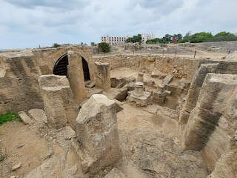

Video #5: (8 seconds)

https://photos.app.goo.gl/dBExfGniDBhKzNxJ9

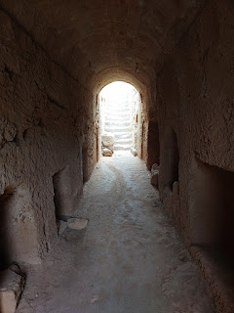

Video #6: (7 seconds)

https://photos.app.goo.gl/8tSfyHHf4mJyPGAk7

'Twas a little bit breezy that afternoon, ha ha.

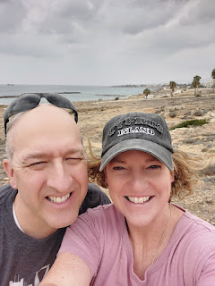

I saw several of these little hyacinth bulbs growing everywhere, some being naively trampled on the paths while others were situated off the pathways, and thus they were more protected.

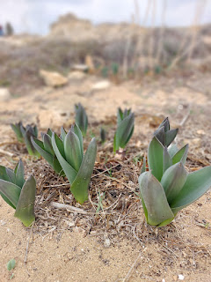

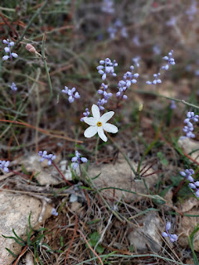

Video #7: (11 seconds)

https://photos.app.goo.gl/rvK8Tu67GzK2BWcN6

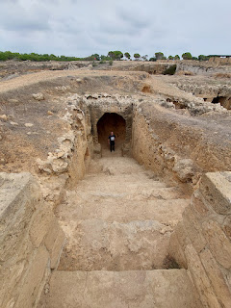

Video #8: (14 seconds)

https://photos.app.goo.gl/k51uUT4WmALe6vqt7

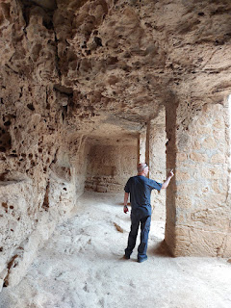

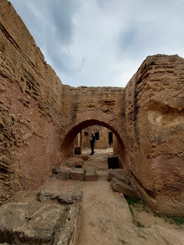

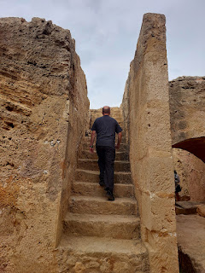

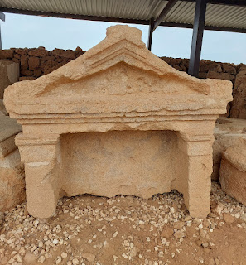

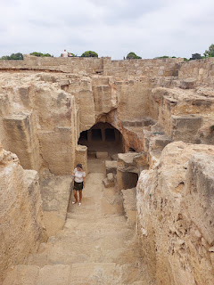

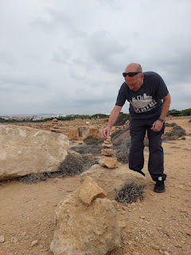

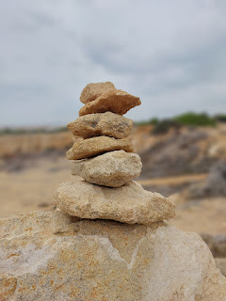

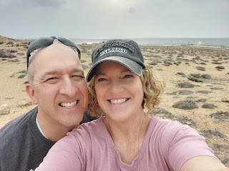

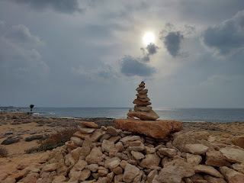

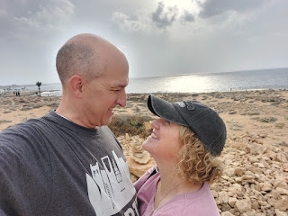

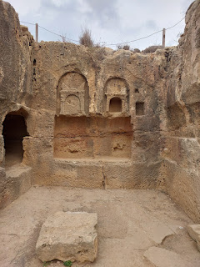

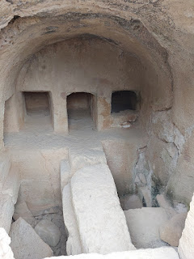

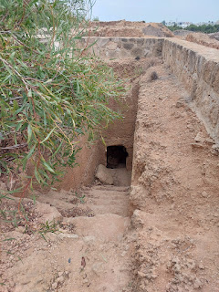

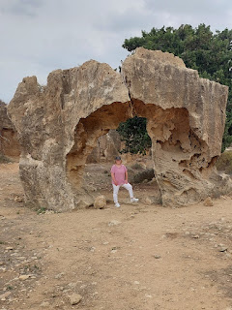

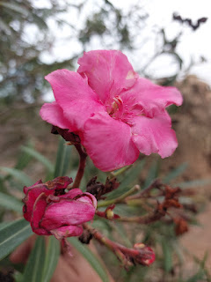

What an amazing experience. My visit to Cyprus seemed to get better and better with each day since my arrival there. I'm so glad we got brave enough to rent a car so we could see some extraordinary places that we would not have been able to see otherwise.

Our next stop was back toward Limassol and east of Paphos. It struck me as somewhat odd to see candy canes and Christmas decorations mixed together with palm trees and sandy beaches. But what else would you do? If I lived in Cyprus, I would definitely put up my Christmas decorations, too!

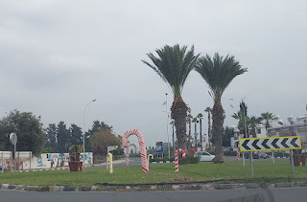

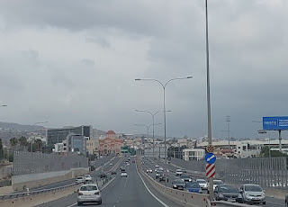

Each time we passed this monumental mosque in Limassol, I was awestruck. I wish I could have seen the inside.

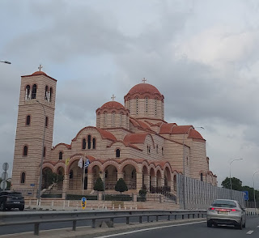

On the outskirts of Limassol, we parked next to a restaurant (more on that in a minute) and walked out to the beach, a very short distance. The beach is called White Stones and it was GORGEOUS. We made it just in time to see the most exceptional sunset that I've ever seen in my whole life.

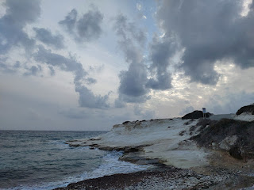

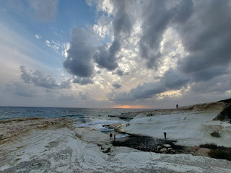

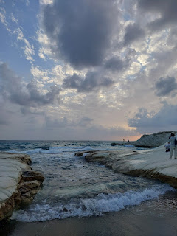

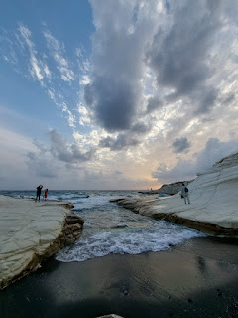

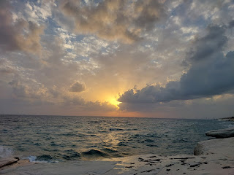

Video #1 of the sunset: (13 seconds)

https://photos.app.goo.gl/PUXf5S1QEVDMaiJ1A

Video #2 of the sunset: (19 seconds)

https://photos.app.goo.gl/aW4pdn2eSvyM2fcL7

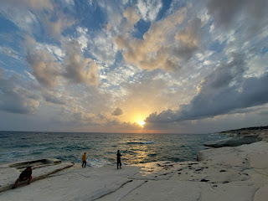

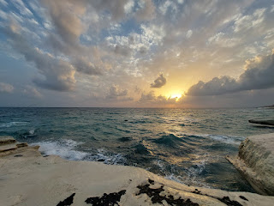

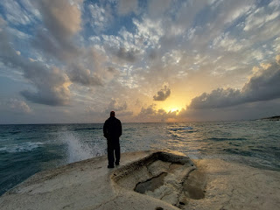

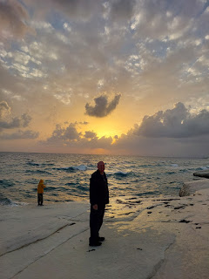

In the photo below, that's Scott - standing way out on the edge of a huge rock that slopes down toward the crashing waves.

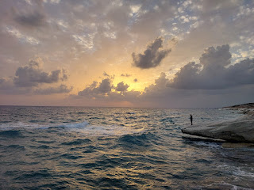

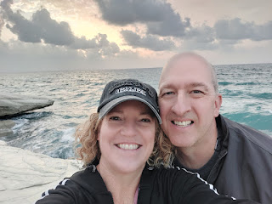

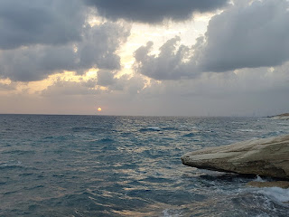

When it appeared that we had seen the last of the sunset, we headed back to the restaurant next to our car. You can see it situated on the water's edge in the photo below. The name of it is Agios Giorgos Alamanou Fish Tavern.

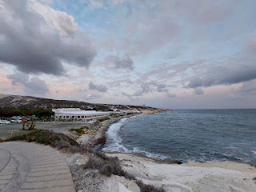

This place is HUGE and has the potential for hundreds of hungry customers. They have lots of fish options, which made me very happy.

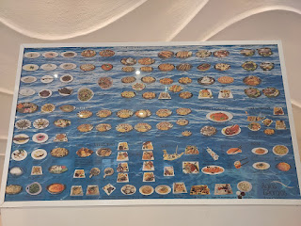

As an appetizer, we ordered garlic pita bread wedges with a delicious Ayiorotiki dip, per the waitress' suggestion. (eggplant salad with a smoky flavor)

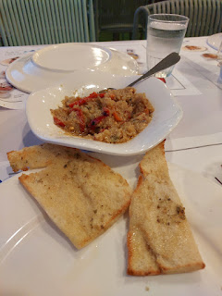

For dinner, we ordered the "Platter for One" and it was more than enough for the two of us.

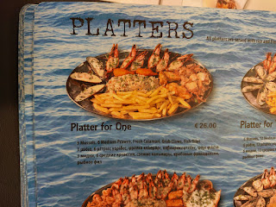

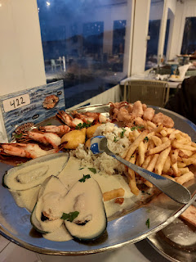

I was in absolute seafood heaven, and I wished that I had 3 stomachs . . .

When you tell them you're ready for the bill, they first bring you a complimentary "dessert", consisting of fresh fruit and toothpicks to eat them with and some VERY sweet crispy pieces of baklava. We couldn't finish them off . . .

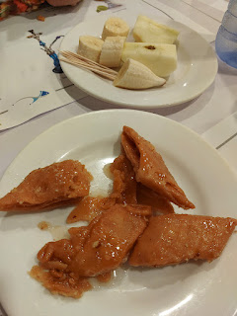

Day Seven:

This was the one Sabbath Day that I spent in Cyprus. It was the last day of our rental car, too, so we drove to church. Otherwise, it would have been a 40 minute walk each way from the hotel. I was especially grateful for the car because it was VERY windy that day, with gusts expected to be over 50 mph at times.

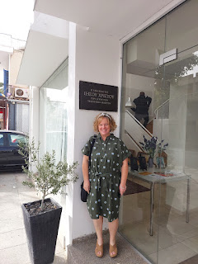

First, I found a sign to take a picture under, but then Scott saw another potential place for a photo that had both the English name of our church and the Greek version. It was a whole lot brighter in that second spot, as evidenced by my squinting eyes  . . .

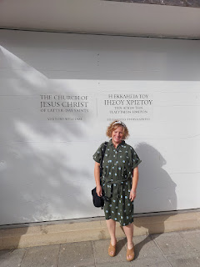

The church service was wonderful. I may have mentioned this before, but in Cyprus there aren't any wards due to a smaller membership in each congregation. Instead, they have "branches", which are quite a bit smaller than an organized ward. In place of a bishop, there is a branch president. Several "branches" make up a district, whereas several wards typically make up a stake.

In Larnaca, the branch president is from Russia. He was very gentle and soft-spoken as he conducted the meeting (seen in the photo below). I had to almost lean in to hear what he was saying. One of the missionaries played the piano for Sacrament meeting - he was from France.

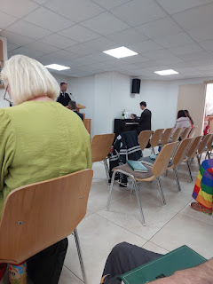

One of the speakers was from the Philippines and the second one was from England. It turned out that she was also the Relief Society president, seen in the chartreuse colored dress with very blonde hair. She spoke of how she had left the church for several years because someone had offended her a long time ago. It took a great deal of patience and effort on her part to finally realize that

people

are flawed, but God and Jesus Christ are not. If we put all of our trust in man, we are bound to be disappointed and hurt. But if we put all of our trust in God and Jesus Christ, we will be blessed no matter what comes our way.

In Relief Society, I learned that Cyprus truly is a melting pot of people from all over the world. The RS president is from England. Her counselors are from Mozambique and Bulgaria. Her secretary is from the Philippines. It was beautiful to have a discussion together and to learn from one another in class.

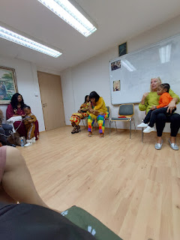

L to R: The RS President (from England), the District RS President (from Germany), and myself.

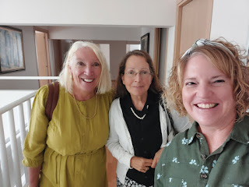

I wish I could remember the name of the Relief Society President, but I cannot . . . She showed me a special photo on the wall on the second floor of the church building, located just outside the RS room. When she finally decided to come back to church, her husband wanted to be baptized as well. Their photo, taken with the missionaries and a few others, is in the far-right column on the bulletin board below.

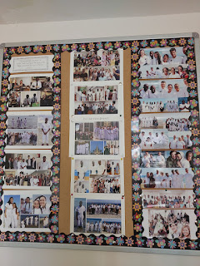

Here's a little closer look - - she and her husband are in the bottom photo (you can see her bright blond hair). They are also in a smaller photo that is 2 photos above that one. Sorry if it's hard to pick them out, but you can click the photo to zoom in.

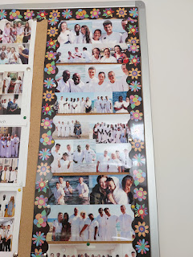

What a beautiful place for a baptism - in the gorgeous Mediterranean Sea. And how precious for someone to have captured all of the smiles and memorable moments and then organized them into a space for all to see when they come to church.

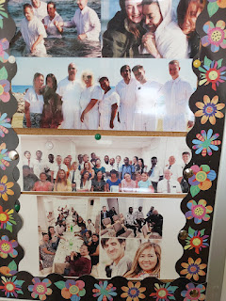

It was stormy and rainy for much of the afternoon. Scott waited for it to subside before taking the rental car back to the airport while I worked on my blog. A little later, we went for a walk along the beach, not only to stretch our legs and get the blood pumping, but to also find a place for dinner.

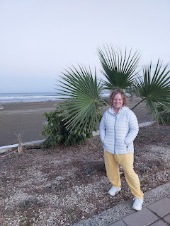

We headed south for the first time all week, toward Makenzy Beach. It was a really nice beach with paved walking paths.

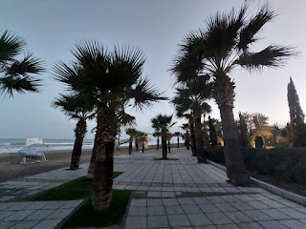

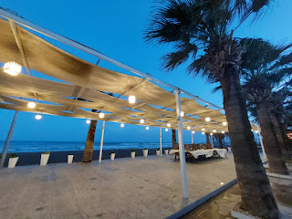

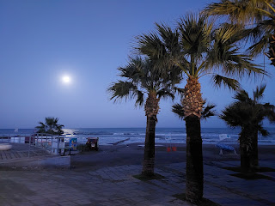

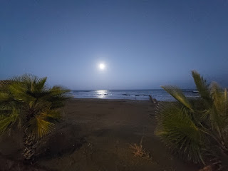

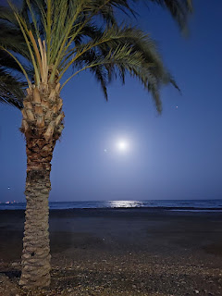

On our way back, we settled on a restaurant called Zephyros. I liked how each restaurant posts their menu outside so you can walk along and see what everyone is offering before deciding where you want to eat. We chose this one because they offered a couple of soups, and they sounded really nice to me.

However, the waiter told us that the soups were not very good and from his description, it sounded like they just take cans of soup, open them up and heat them to serve to the customers. I settled on the typical Cypriot Salad (Greek Salad), which I LOVE.

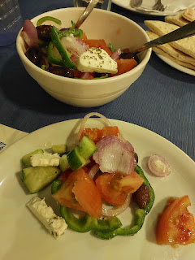

And some local fish, Sea Bream, which I did not love. It was overcooked and dry without any flavor at all. How sad. I did my best to pick at it, but it was not very enjoyable. We decided to bring it back to the hotel in a container and share it with the neighborhood cats.

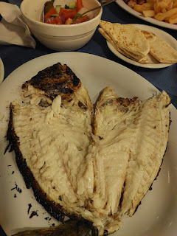

Once again, when you ask for the bill, they first bring you a platter with some typical Cypriot desserts. In this case, they served us Glyka tou Koutaliou (spoon sweets).

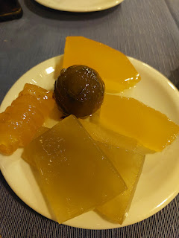

The most common spoon sweets are made from figs, cherries, watermelon rind, and citrus peel, to name a few. They are very sweet by the time they are soaked in water + cooking lime to become crispy, then in water and lemon juice to become shiny and preserve their color, and lastly, they are gently boiled in sugar over several days.

The website with the best description is:

Glyka tou Koutaliou (Spoon Sweets - Preserves) (visitcyprus.com)

Video of the crashing waves on our walk back to the hotel: (22 seconds)

https://photos.app.goo.gl/EWWsnHrdAqesELfSA

We asked ourselves back at the restaurant if we should feed the cats or not. Ultimately, we based our decision on what would our two oldest granddaughters want us to do.

Definitely feed the cats

.

Video of the ravenous cats eating our fishy leftovers: (27 seconds)

https://photos.app.goo.gl/YKEeVEzMinNt9wGfA

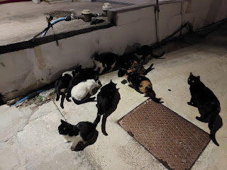

Day Eight:

Scott had a few other things to take care of again, so I was on my own for entertainment for the day. I had watched him wash his clothes in the bathroom sink a few days before, and I decided to give it a go. He had already looked into having the hotel do it, but unlike Agadir (Morocco) where they wash your clothes every single day, in Larnaca, there is a hefty fee for doing your wash. (About $30) The nearest laundromat was an inconvenient 25 minute walk away. So, yeah, the sink worked just fine. Scott had already purchased some laundry detergent at the little grocery store around the corner.

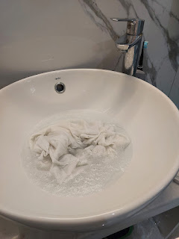

After washing and rinsing and squeezing everything out as best as I could, I hung my clothes out to dry on the balcony, draping them over the two chairs and table to soak up some sun.

Then I worked on this blog and my Thankful List of 2023 blog for several hours. I laid out by the pool for a bit, as well, and read some of the book I had brought with me.

I went for a walk and chatted with my sister, Charmaine, as I walked along the "Med", as the locals refer to it.

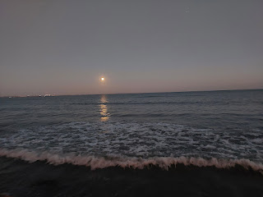

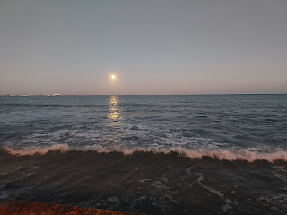

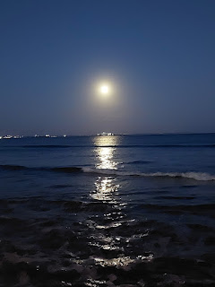

Eventually, Scott was available and we mapped out our evening together. We picked up some dinner and ate it in our room. We walked over to the grocery store again, so I could pick out a few items to bring back to the U.S. to share with my family over Christmas. There were some unusual flavors of chips in the store, but I did not buy any of them, ha ha. Jacob was the only one to respond that he WOULD be interested in trying this crazy flavor.

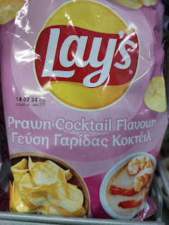

Day Nine (Final Day):

I had roughly 2/3 of the day to relax and enjoy before heading to the Airport. It was toasty warm again - yay! - so I laid out by the pool for a bit and read my book. Scott was able to hang out with me for a little while in the middle of the day, so we went for a walk down to Makenzy Beach again.

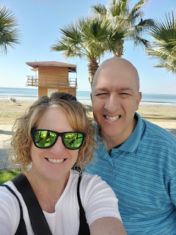

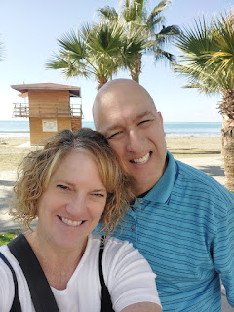

I wanted to try to get a video of a plane coming in to land over the beach. The airport is really close, so the planes fly very low overhead here. I didn't get close enough to the

best

spot for a video, but I did get this pretty good one: (21 seconds)

https://photos.app.goo.gl/Ehu5wF6PsRpb5Gwc7

One of the most stunning flowers that I saw in Cyprus was right outside the main entrance to our hotel.

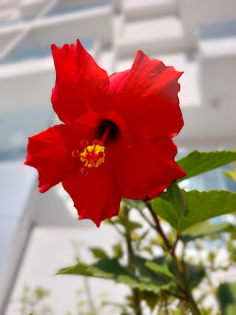

And that's a wrap.

8+ days in a foreign land that I couldn't disclose during the time I was there. I couldn't share the beauty and the specifics of what I was experiencing with anyone other than Scott. I was allowed to share a few photos with close family, as long as they weren't too revealing as to where I was. It was incredibly hard to keep my mouth shut when I like to share stuff. I'm just grateful that I get to share it all now.

The Larnaca Airport was all dressed up for Christmas, and what a beautiful sight to see as I prepared to fly back to Italy.

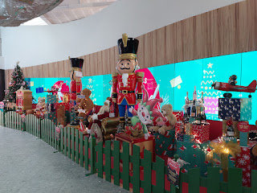

One last thing: At the Larnaca Airport, you have to use a kiosk to prepare to go through customs as you leave Cyprus. You put in your passport info and then it prints out a ticket (or a receipt) to take to the customs agent. But OH BOY . . . it looked like I was heading to jail at first, LOL.

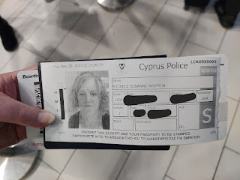

If you've made it this far, there's a little extra feature below for your enjoyment.

Scott has been learning javascript. He wanted to see if he could embed a program into my blog.

0

Decrease

Reset

Increase

/* Styles for everything */  
 body {  
 font-family: sans-serif; /* Add a default font for the body */  
 }  
  
 #lblCount {  
 display: block;  
 text-align: center;  
 font-size: 10em;  
 font-family: Arial;  
 }  
  
 #btnContainer {  
 text-align: center;  
 }  
  
 .buttons {  
 padding: 10px 20px;  
 font-size: 1.5em;  
 color: whitesmoke;  
 background-color: hsl(214, 100%, 74%);  
 border-radius: 5px;  
 cursor: pointer;  
 transition: background-color .3s;  
 }  
  
 .buttons:hover {  
 background-color: hsl(286, 100%, 74%);  
 }

// Your JavaScript code here  
 const btnDecrease = document.getElementById("btnDecrease");  
 const btnIncrease = document.getElementById("btnIncrease");  
 const btnReset = document.getElementById("btnReset");  
 const lblCount = document.getElementById("lblCount");  
 let count = 0;  
  
 btnDecrease.onclick = function() {  
 count--;  
 lblCount.textContent = count;  
 };  
  
 btnIncrease.onclick = function() {  
 count++;  
 lblCount.textContent = count;  
 };  
  
 btnReset.onclick = function() {  
 count = 0;  
 lblCount.textContent = count;  
 };